**SanDisk Memory card**

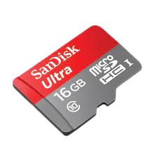 PKR 1,200 Pro

A memory card is a type of storage device that is used for storing media and data files. It provides a permanent and non-volatile medium to store data and files from the attached device. Memory cards are commonly used in small, portable devices, such as cameras and phones. A memory card is also known as a flash card.

A memory card is mainly used as a primary and portable flash memory in mobile phones, cameras and other portable and handheld devices. PC Cards (PCMCIA) were a predecessor of modern memory cards that were introduced for commercial purposes. Besides providing non-volatile media storage, a memory card also uses solid state media technology, which lowers the chances of mechanical problems, such as those found in traditional hard drives.

**Size :** 4.5

**Speed :** 1,6000rpm

**color:** Red & Gray

**Species :** 16GB

**Brand Name :** sanDisk

**Products Status** Good New